**Linoleum Block Printing LESSON PLAN FORMAT**

Teacher: Katy Lehman

Lesson Title: Linoleum Block Printing (Two part lesson)

Grade Level: Eighth Grade  
Number of Students: 18 Students

**BIG IDEA**

Linoleum Block Printing

Printing Press

Clashing Patterns

Contrasting Light and Dark

Symmetry

**ART / ARTIST(S) OF RELEVANCE**

M.C. Escher

Maurits Cornelis Escher (1898-1972) was a Dutch graphic artist who made mathematically inspired prints. Despite current wide popular interest, Escher was neglected in the art world for a long time, even in his native Netherlands. He had his first retrospective exhibition when he was 70. In the 21st century he became more widely appreciated with exhibitions around the world and his artwork showcased in hundreds of museums. Mathematics- His work features mathematical objects and operations including impossible objects, explorations of infinity, reflection, symmetry, perspective, and tessellations. Nature- Escher drew from nature, making studies of insects, landscapes, fish, plants and more. He traveled in Italy and Spain sketching buildings, townscapes, and architecture. Escher’s prints emphasize clashing patterns seen in nature, architecture, and human designs. The clashing patterns exhibit his play on real vs. fantasy. Some of his patterns appear to morph and shape into the clashing pattern. Birds morph into fish or a staircase morphs into a human. Escher shows symmetry in his artwork. He also uses contrasting light and dark colors to emphasize the different patterns.

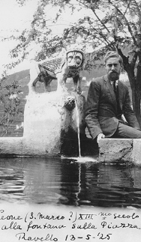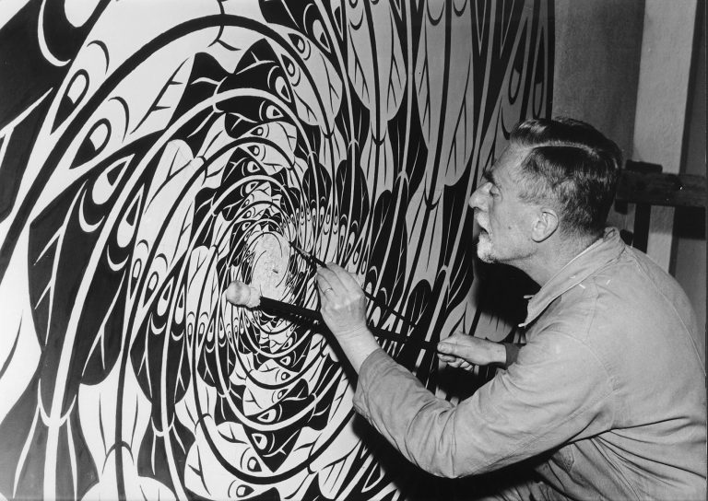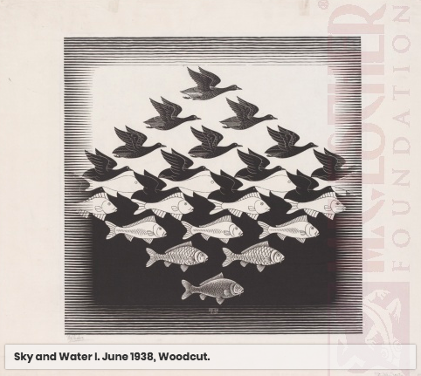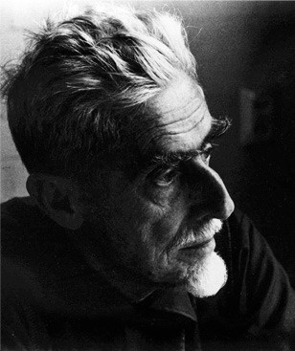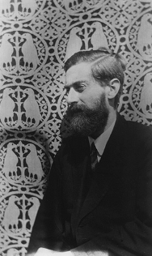

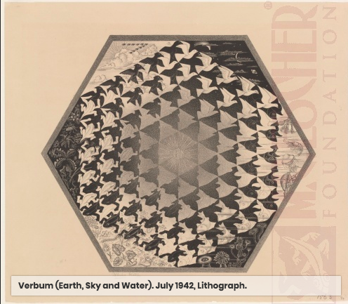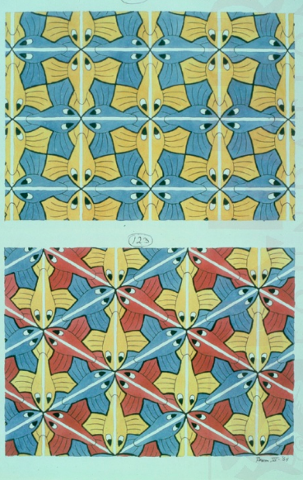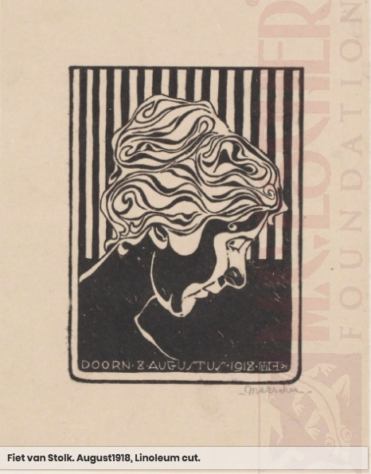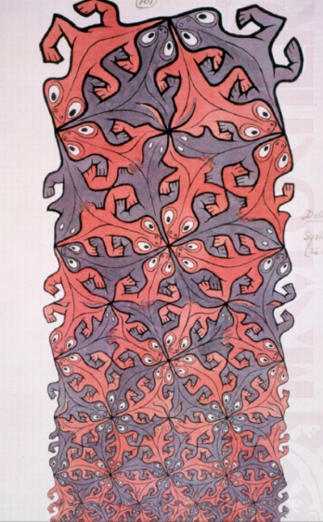

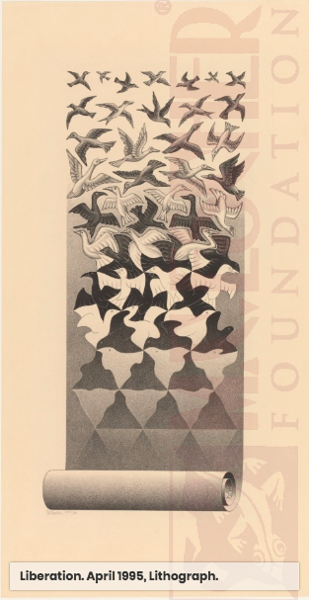

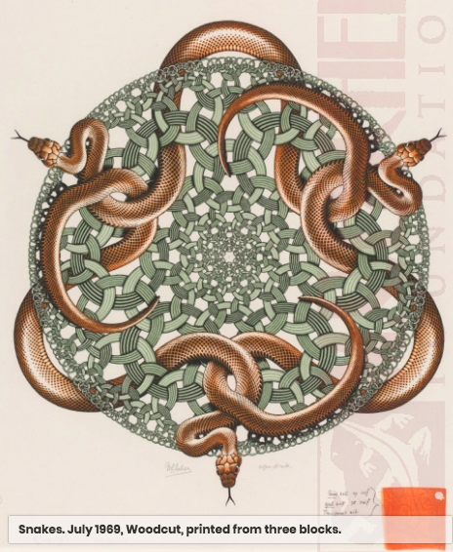

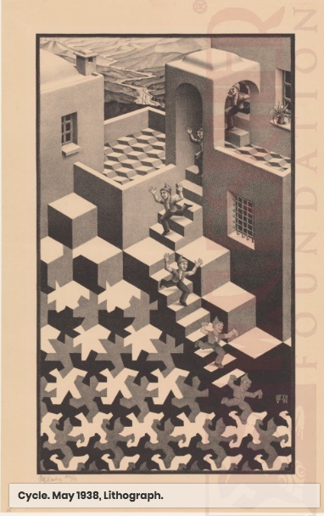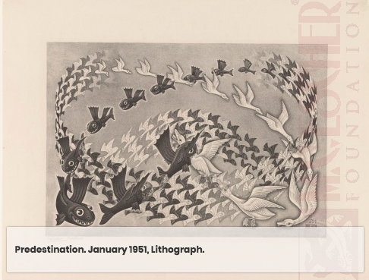

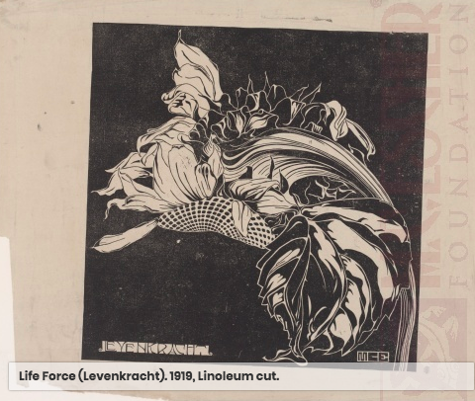

**SAFETY HAZARDS**

* Students will use gauges to cut out the patterns and designs in their linoleum blocks. They will be instructed to cut away from themselves and never have their opposite hand/fingers close to the gauge. They will also use a wood block to hold the linoleum block in place and act as a barrier for the printing tools.
* Students will be able to work freely around the open studio; therefore, they need to be respectful of all the materials, tools, and artists in the space.

**INTERDISCIPLINARY CONNECTIONS**

* Students will connect this lesson to math as they focus on symmetry and patterns. Students will also learn about an artist who focuses his artwork on mathematical tessellations, symmetry, perspective, and more.

# LESSON OVERVIEW

For this 2 part lesson students will learn about artist M.C. Escher who became famous towards the very end of his life and after he passed away. Now he is well known for his woodcuts, linocuts, lithographs, linoleum cuts, and screen prints that feature mathematical objects and operations including impossible objects, explorations of infinity, reflection, symmetry, perspective, and tessellations. Escher drew from nature, making studies of insects, landscapes, fish, plants and more. He traveled in Italy and Spain sketching buildings, townscapes, and architecture. Escher’s prints emphasize clashing patterns seen in nature, architecture, and human designs. The clashing patterns exhibit his play on real vs. fantasy. Some of his patterns appear to morph and shape into the clashing pattern. Birds morph into fish or a staircase morphs into a human. Escher shows symmetry in his artwork. He also uses contrasting light and dark colors to emphasize the different patterns. For this lesson students will start by drawing a design for a pattern that has two clashing patterns. The patterns should show a contrast between light and dark. They will learn that the more they carve away the lighter that pattern will be, and the less they carve then the darker that design will be. The design will also feature some element from nature. They will be encouraged to create symmetry in the design by doubling the nature element or add another nature element that relates to the other. Students will use graphite paper to transfer their design onto a linoleum block. Then the students will use gauges to carve the design into the block. The second part of this lesson will be the actual printing process. Students will use brayers, inking plates, block ink, and a printing press to create 4 satisfactory prints.

**LEARNER OBJECTIVES**

1. Students will learn about M. C. Escher.
2. Students will create a sketch that includes two different patterns, when the design is printed one pattern should be lighter and one should be darker. Students will learn that the more they carve away then the less ink will show, but the less they carve away then the more ink will show because the relief print from the linoleum block will show ink where the block is raised and not carved away.
3. Students will create a sketch that includes some element of nature. The students will double this element, or they can create a design that has two elements from nature that relate to one another. This will show their understanding of symmetry and making a cohesive print.
4. Students will carve their design into a linoleum block. The students will practice safety when using the carving tools, linoleum block, and wooden board.
5. Students will use block printing ink to print their designs onto cardstock paper. Students are required to make a series of 4 satisfactory prints. 1 black on white print, 1 white on black print, and 2 exploratory prints. Students are allowed to create more but this is the minimum to show they have a strong understanding of the printing and inking techniques.
6. Students will be able to use the printing press.

**NATIONAL ART STANDARDS**

VA:Re.7.1.Ia Hypothesize ways in which art influences perception and understanding in human experiences.

VA:Re.7.2.Ia Analyze how one’s understanding of the world is affected by experiencing visual imagery.

VA:Cn11.1.Ia Describe how knowledge of culture, traditions, and history may influence personal response to art.

**PENNSYLVANIA DEPARTMENT OF EDUCATION STANDARDS**

9.1.12.F Analyze works of arts influenced by experiences or historical and cultural events through production, performance, or exhibition.

9.1.12.H Incorporate the effective and safe use of materials, equipment and tools into the production of works in the arts at work and performing spaces.

**MATERIALS NEEDED FOR LESSON**

1. Linoleum Block
2. Wood Block
3. Brayer
4. Ink Plate
5. Block Ink
6. Cardstock paper
7. Gauges
8. Printing Press

**TEACHER ACTIONS / EXPECTED LEARNER ACTIONS**

|  |  |
| --- | --- |
| **Teacher Actions** | **Expected Learner Actions** |
| 5-10 Minutes: Teacher welcomes students into the classroom. The seats are arranged in a way so that all the students can see the projected power point. The teacher asks the attendance question “Do you remember what object from nature is in your print design?”.  Students will then go around the room individually answering what the design is on their print. | 5-10 Minutes: Students come in to the room and take a seat at one of the stools in the center of the room. Students are quiet and respectful as they answer the attendance question. |
| 10-15 minutes: Teacher gives demonstration for completing the carving of the linoleum block. Then teacher transitions into demonstrating the printing process. This includes how to use the brayer, inking plate, and printing press. | 10-15: Students respectfully listen to and watch the teacher’s demonstration. |
| 40-60 minutes: Teacher will instruct the students to work. The teacher will walk around the room and assist students who need. | 40-60 minutes: Students work freely around the art space to finish carving their block and then move on to the printing process. They will create at least 4 prints. |
| 10-20 minutes: Teacher will explain and then distribute the reflection sheet to the students. | 10-20 minutes: Students will fill out their reflection sheet. Students who finish everything early can draw in sketch book or create a mini-linoleum block and prints. |
| 5-10 minutes: Teacher will ask students to help with the clean up process who are clearly finished with their work. The teacher will set out two soapy water buckets to clean the brayers and knives in. | 5-10 minutes: Students will clean up the carving space and the print space. |

# ENDING THE LESSON

**Closure of Lesson:** To end this lesson, students will each have a series of 4 prints (or more). They will place the prints on the drying rack and clean up the workspaces. Students will then have a closing conversation. The teacher will facilitate questions about the carving process and the printing process. They will discuss discoveries, successes, and failures. The teacher will also facilitate questions about how each student used contrasting light and dark patterns in the carving/design process, and then how it came out in the printing process. Can you see the contrast between the light and dark? Can you see the clashing patterns in your design? Did you create a design that was inspired by nature and shows symmetry or repetition? Students will go around the room and describe their design and patterns to the class as a way to self reflect and as a means for the teacher to asses their engagement, understanding, and completion of their artwork. In addition, students will be given a reflection sheet. The reflection sheet (below) will give the teacher the ability to understand the students’ thoughts and feelings towards their artwork, their experience in the studio, and their feelings toward the teacher.

8 Weeks have passed and we have created Palette Knife Paintings, Linoleum Block Prints, and Self Proposed Projects! For Ms. Lehman’s last day at Falk please answer in a few short sentences…

1. What is something you learned?
2. What is something we did in the studio that you loved?
3. What is a tip you have for me as a teacher?

**THE CLASSROOM AS A THIRD TEACHER**

The classroom will be set up with three large tables and stools around the room. Students are able to work wherever they feel comfortable in the room. At the front of the room will be a board with the question “What element from nature are you creating in your print design?” and a checklist of the goals for the class. At the beginning of class students will gather to each answer the opening question. This allows for students to remind themselves what they are working on, but also to have an understanding of what other artists are creating in the studio. Students create an art dialogue and learn about one another through what they create and express in their artwork. Students will also gather around the front board to watch a demonstration from the teacher for completing the carving process, and then beginning the inking and printing process. Students will be able to reference the checklist through out the entire class and also during the demonstration. Throughout the room the materials will be placed for students to easily access and work. In the beginning of the class almost all students will be continue to carve their blocks, so on the tables will be carving tools and wooden blocks. As students finish, we will designate a table for inking. On this table will be block ink, inking plates, brayers, and numerous colors of cardstock. Throughout the class all students will finish carving and the studio space will be all for printing. Students will place their prints on the drying rack. The open studio space allows for students to work at their own pace, while also having the freedom to move their bodies and create art in a dynamic way.

**ASSESSMENT**

1. Students will be assessed on their ability to listen respectfully to presentation, instructions and during demonstration. Students are actively told in the art studio to “practice the art of respectfully listening” and are set to a high standard when it comes to this expectation in the classroom because the majority of the class students are able to engage independently in their art making and artistic conversation.
2. Students will be assessed on their engagement in their art practice. In the hour and 35 minute class period, they will have enough time to complete their art work and create a piece of artwork that they are proud of, nor did not rush to complete. This also includes a student’s ability to follow all safety procedures through out the class period.
3. Students will be assessed on their ability to follow the instructions that are presented and demonstrated for them in the beginning of class.
4. At the end of the class, students will be assessed on their ability to engage in artistic and intellectual conversation about their artwork, the process, and the content they learned about radial symmetry.

**ACCOMMODATIONS FOR INDIVIDUAL STUDENTS**

**Student 1:** The first student with a student support plan in this class needs support for executive functioning, fine motor handwriting skills, dyslexia, and self-advocacy skills. To help this student to understand instructions I will keep the goals list on the front board clean and easy to read. I will also explicitly show Reed how to perform the tasks in a group demonstration and then also one-on-one once he has set up his work space and has all of his materials ready. I will show him how I do it and then allow him to perform the tasks as I offer further advice and encouragement. Through out the demonstration I will have provided a written representation of the goals, a visual demonstration where I physically perform the tasks, and an auditory description of the steps and goals. Throughout the class I will encourage this student to seek additional clarification and support from the teacher to assist his self-advocacy skills. To support this student’s environmental adaptations I will have him/her placed in the room near the source of instruction and away from other students in the class who cause distractions. I will also walk around the room frequently to assess his comprehension and understanding of the processes.