**Stop Motion Seventh Grade LESSON PLAN**

Teacher: Katy Lehman

Unit Title: Stop Motion

Lesson Title: Abstract Representational Painting

Grade Level: Seventh Grade  
Number of Students: 15 Students

**BIG IDEA**

Mapping out identity

Transform concrete ideas into an abstract representational painting

Create a stop motion video of the student’s abstract painting from start to finish

**ART / ARTIST(S) OF RELEVANCE**

Every year in May, the city streets light up in Sydney, Australia for the annual Vivid Festival. In 2018 Jonathon Zawada was appointed as the Director of the Lighting of the Sails of the Sydney Opera House. He created a 15-minute video, titled “Metamathemagical”, that was projected onto the unique architecture for the three-week duration of the festival. Zawada explores the “idea of creation from both micro/individual perspective and also the macro/cosmic perspective” and the artwork “draws upon Australian flora and fauna geology”. The video projection was described as “Aggressively acidic with an undertow of melancholia, Metamathemagical begins with a series of improbable 3D geometries in candy colours skittering across the white-tiled pinnacles of Jørn Utzon's landmark building. These coalesce into bubbly, crystalline shapes which in turn evolve into retina-spinning renderings of native flora, reptiles and birdlife.”

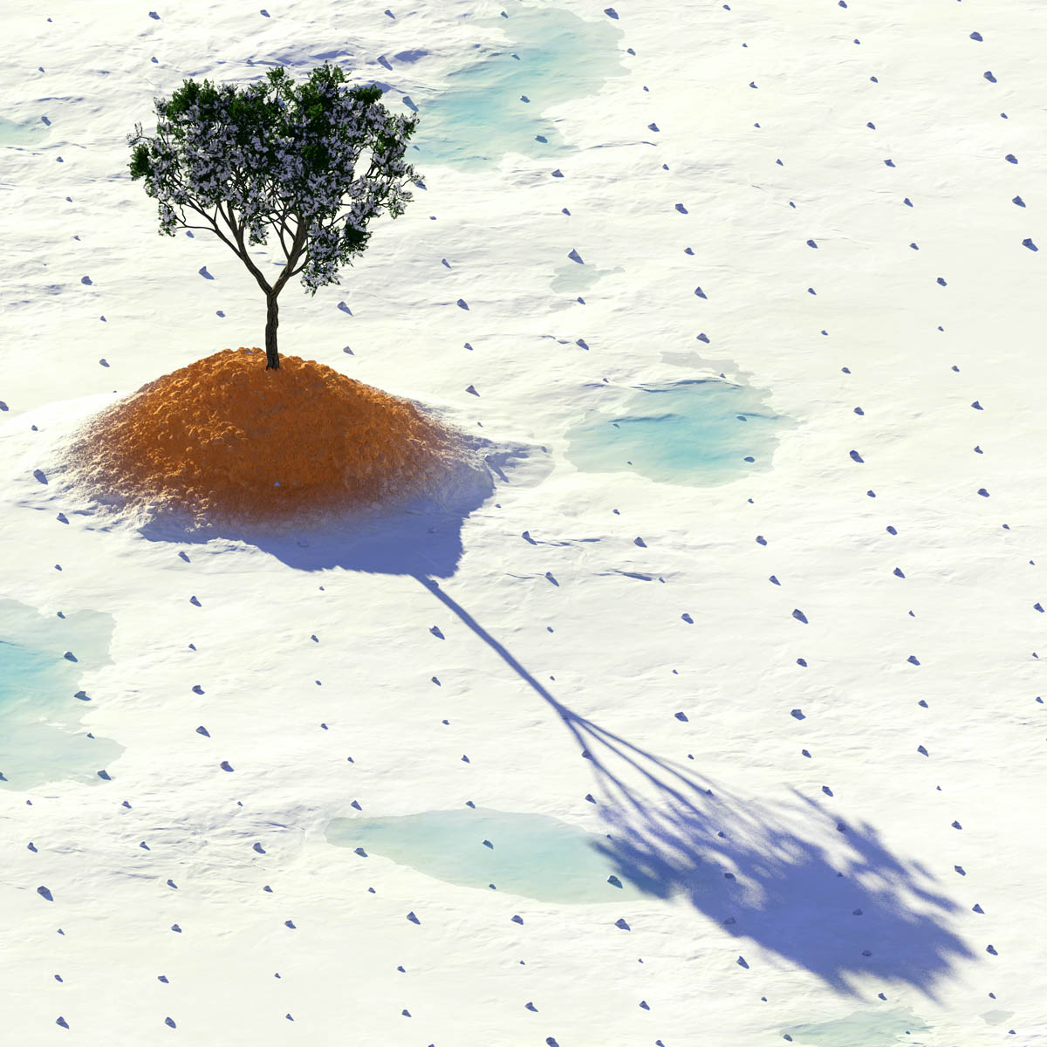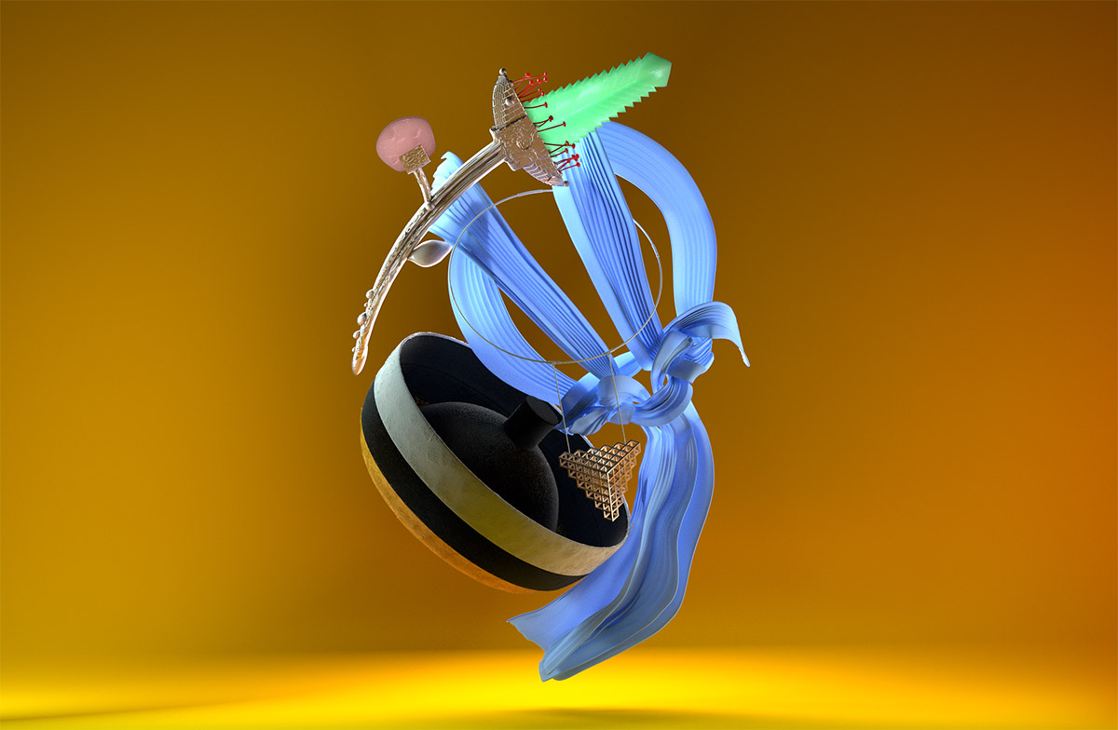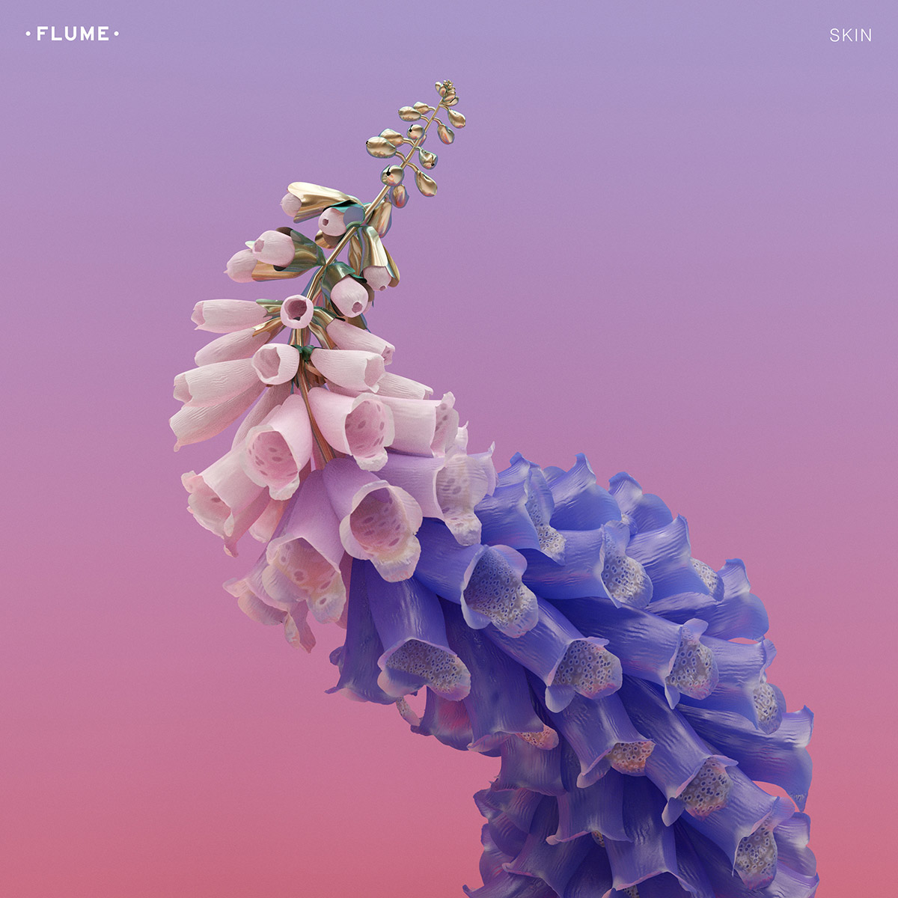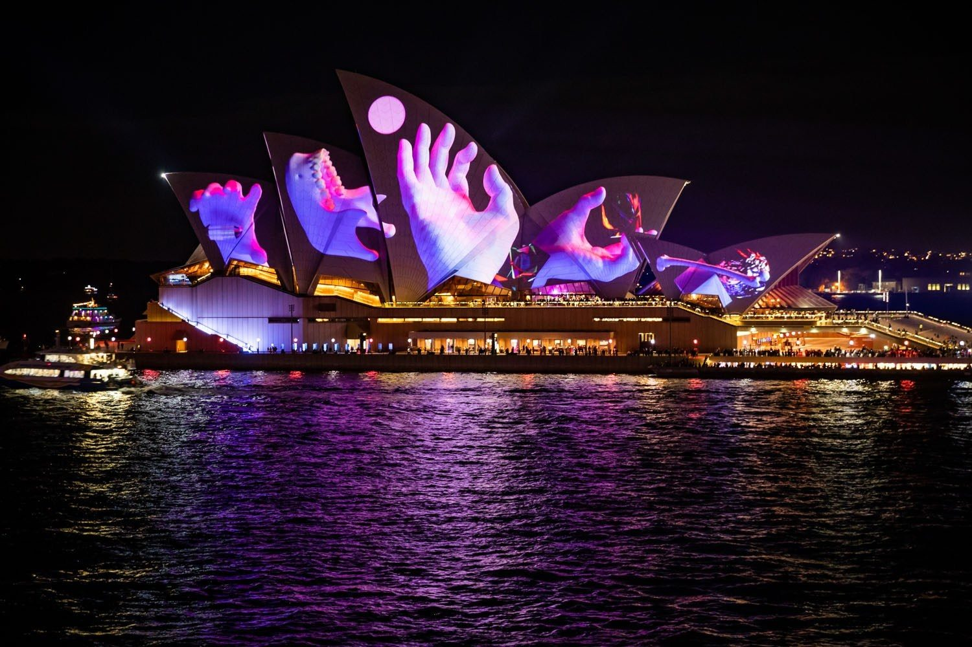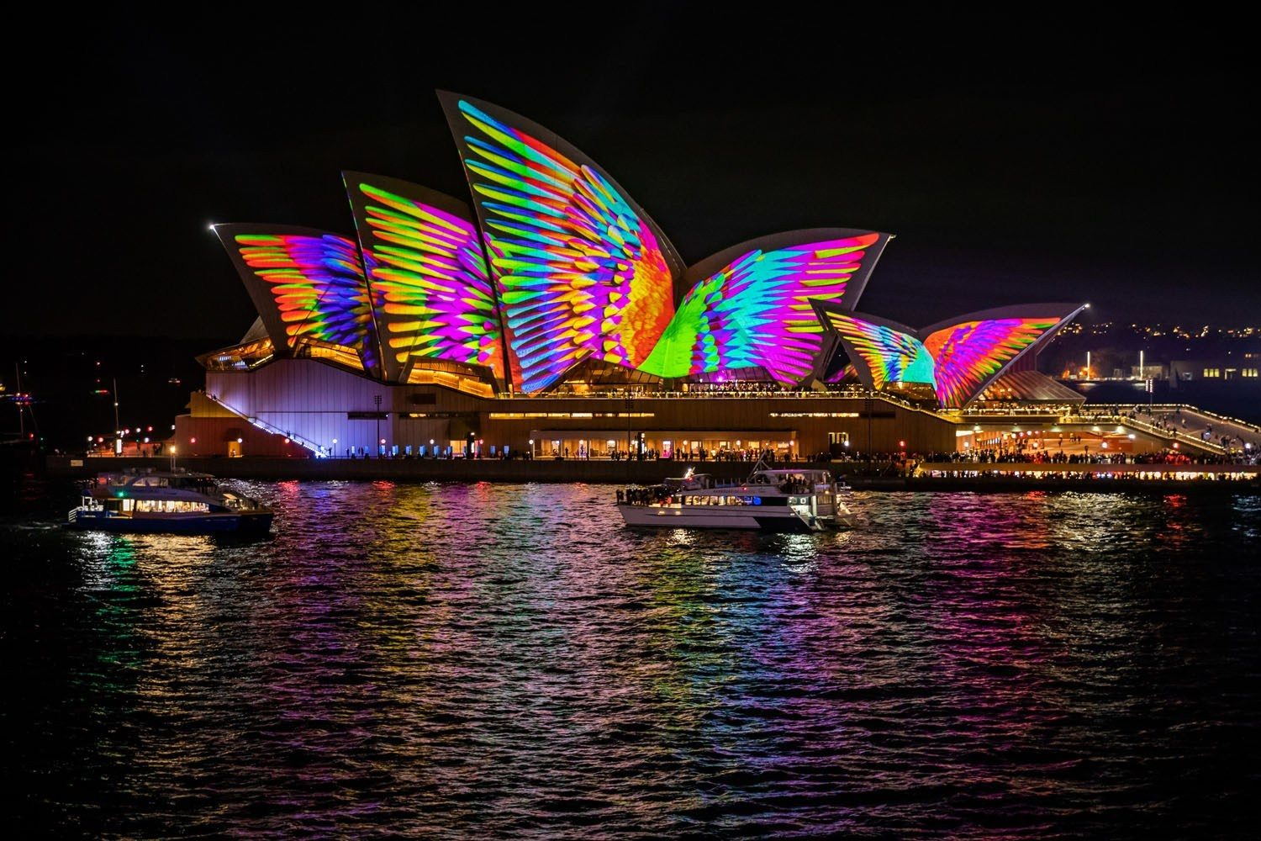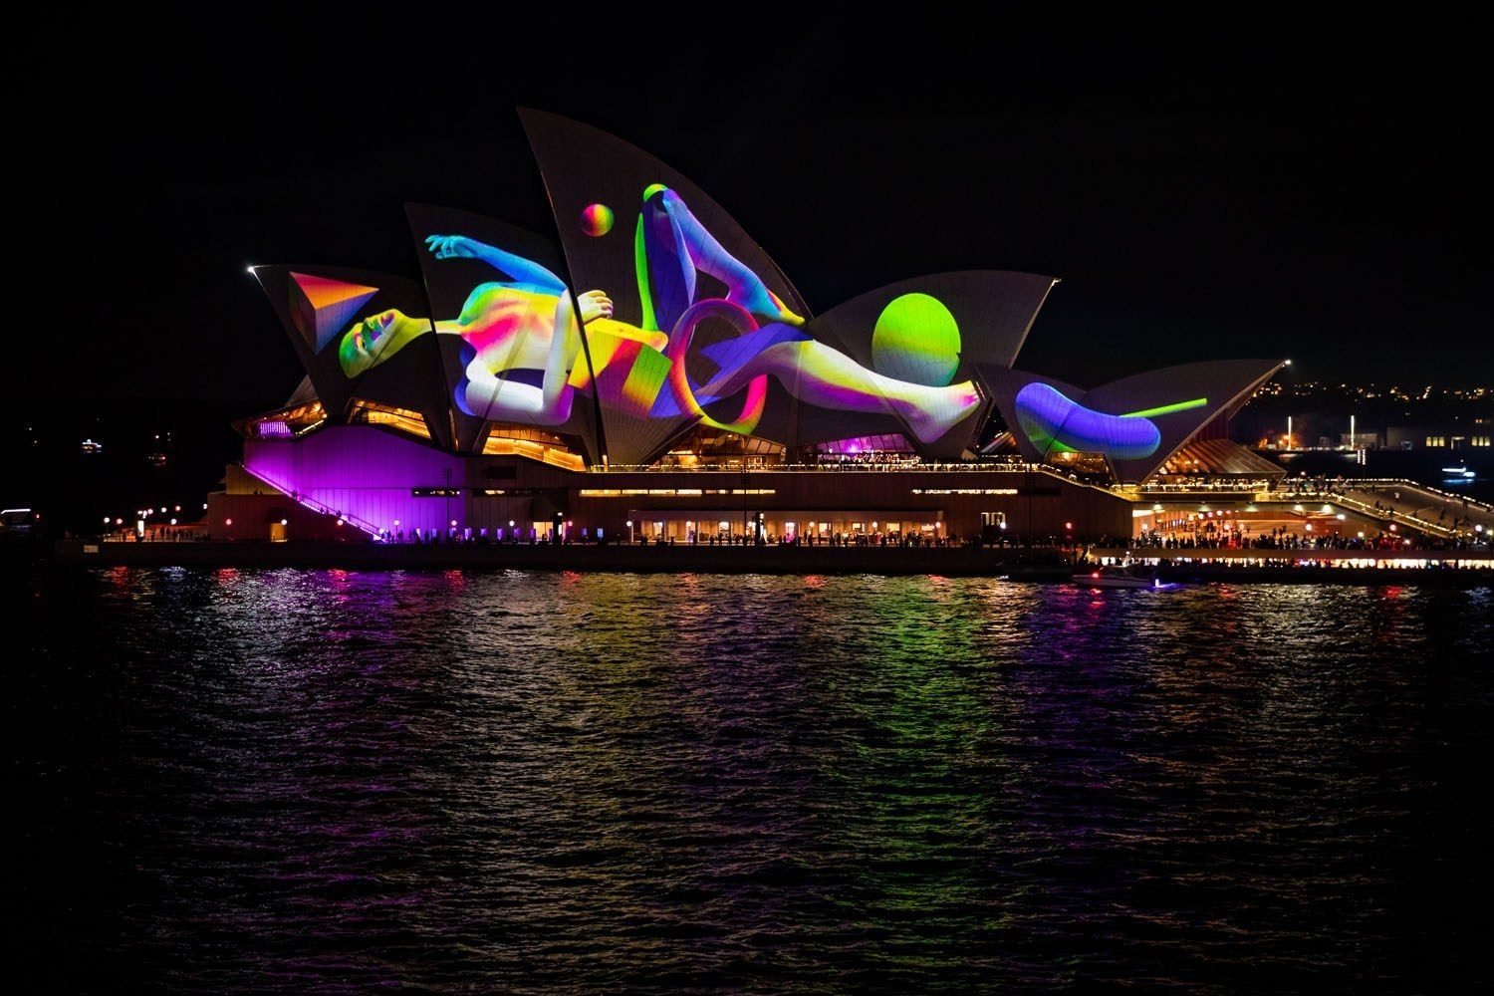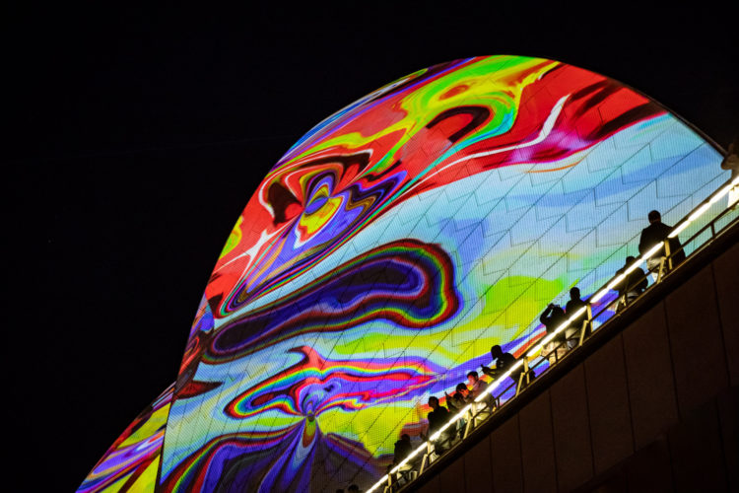

**INTERDISCIPLINARY CONNECTIONS**

Students will connect their art making to social studies as we focus on current events happening in another country. Students will learn about a famous Australian artist who creates a graphic design video projection for an annual music, art, and light festival, Vivid, that is held in Sydney, Australia. The students will also connect their art making to technology as they explore iStopMotion and iMovie on an iPad. They will become experts of the two applications. They will learn how to adjust the settings, effects, and displays on the two applications. Additionally, students will connect their art making to language arts and writing as they create concept maps of their identity. They will write and talk about the elements of their identity that relate to their interests/hobbies, background, personality traits, and physical traits. Then students will write and talk about how they will take these concrete ideas and transform them into abstract representations.

# LESSON OVERVIEW

The focus of this lesson is to take inspiration from visual artist Jonathon Zawada, who created a video that represents the ecology, environment, and identity of Australia through abstract digital art. The “Metamathemagical” video was projected onto the Sydney Opera house for millions of people to see during the Vivid Sydney Festival. Students decided what their own identity was by creating a concept map that includes their interests, background, personality traits, and physical traits. Students then took these concrete ideas and decided how they will artistically transform them into abstract representations. In this lesson, students will be using the iStopMotion App on iPads, small canvases, and acrylic paint to create abstract representational paintings that are captured in Stop Motion. Students combine technology with their art making to transcend the process of painting. They will not simply focus on the final painting, but they will emphasize the art making process as they capture it in a Stop Motion video. Students will learn how to transition from one part of their painting into another and discovery through this exploration how they choose to do so and what the art making process will look like in the final video. The final Stop Motion video will also be edited with visual filters and music when they are finished. They will then project the video onto their Dream Bedrooms, a “building” that is meaningful to each child.

**LEARNER OBJECTIVES**

1. Students will create a concept map of their identity that includes:
   1. Interests/hobbies
   2. Background (race, religion, hometown)
   3. Physical characteristics (gender, ethnicity, hair or eye color)
   4. Personality traits/Emotions
2. Students will plan how they will transform these concrete ideas into abstract forms:
   1. Color
   2. Texture/Pattern
   3. Imagery/Symbols
3. Students will create a stop motion video
   1. Set up space to paint and use ipad
   2. Use the istopmotion app on the ipad
   3. Record the painting process
   4. Transfer the istopmotion to imovie
   5. Add effects and sound
   6. Send video to google drive
   7. Project the video

**NATIONAL ART STANDARDS**

VA:Cr1.2.7a Develop Criteria to guide making a work of art of design to meet an identified goal

VA:Cr2.3.7a Apply visual organizational strategies to design and produce a work of art, design, or media that clearly communicates information or ideas.

VA:Pr4.1.7a Compare and contrast how technologies have changed the way artwork is preserved, presented, and experienced.

**PENNSYLVANIA DEPARTMENT OF EDUCATION STANDARDS**

9.1.8.H Demonstrate and maintain materials, equipment, and tools safely at work and performing spaces.

9.2.8.G Relate works in the arts to geographic regions.

**MATERIALS NEEDED FOR LESSON**

1. Canvas
2. White paper
3. Acrylic Paints
4. Paint brush
5. Water
6. iPads
7. Containers to hold the iPads
8. Sketchbooks

**TEACHER ACTIONS / EXPECTED LEARNER ACTIONS**

|  |  |
| --- | --- |
| **Teacher Actions** | **Expected Learner Actions** |
| 5 minutes: Teacher welcomes students into the class and instructs them to sit where they can see the projector.  Teacher takes attendance and asks an opening question: do you know what part of your identity map you will create in abstract representational painting this class period? | 5 minutes: Students come to art making seats where they can see the projector board.  Students answer attendance question. |
| 5 minutes: Teacher shows her example of stop motion video. Teacher asks the students: How does this video show transitions from one element of my identity map into another element?  Teacher facilitates class discussion about transitioning through painting. | 5 minutes: Students respectfully watch the teacher example stop motion video.  Students engage in artistic and intellectual conversation about how the video shows transitions through painting. They discuss how they can show these transitions as well. |
| 25 minutes: Teacher instructs students to get their materials and start working on their projects.  Teacher walks around the room offering help, critique, and inspiration. | 25 minutes: Students get the materials they need to create.  Work time |
| 5 minutes: Teacher facilitates clean up. But instructs students to sit down with their sketchbooks when they have finished clean up. | 5 minutes: Students clean up then sit down with their sketchbooks. |
| 10 minutes: Teacher asks the students to look at their identity map and think about what they have created so far in their abstract paintings and what they still have to create. Teacher asks closing question: What have you created so far in your painting from your identity map? | 10 minutes: Students look through their sketchbooks and internally reflect on what they have created so far from their identity maps and what they still have yet to create.  Students engage in artistic and intellectual conversation about what they have painted so far. |

# ENDING THE LESSON

**Closure of Lesson** To end each lesson, students will clean up their workspace. Students know what number their iPad is and place it in its appropriate spot in the iPad cart. Students place their canvases on the drying rack with their names on the back. Students will engage in artistic and intellectual conversation as a class about what they created, their experience, and their process in art that period.

**Transition to Next Lesson** Students will have an idea of what they will create on their stop motion painting next. They can discuss this in the closing conversation. If they are unsure what to paint next, students can reference their sketchbooks where they wrote out what they will incorporate for their four categories on their identity map and how they plan to represent this in abstract paintings.

# REFERENCES TO MATERIALS CONSULTED

<http://zawada.art/2018/08/30/mark-pritchard-under-the-sun/>

<https://www.afr.com/life-and-luxury/design/meet-jonathan-zawada-the-multidisciplinary-creative-lighting-up-vivid-sydney-20180503-h0zm6n>

<https://www.collider.com.au/lunar/jonathan-zawada-vivid-2018-sydney-opera-house-sails-vivid-2018-metamathemagical>

**THE CLASSROOM AS A THIRD TEACHER**

Every art lab the room will be set up with materials available for the students. This will include iPads charged and ready, white paper, canvases, containers to hold the iPads, paint, palettes, paintbrushes, and water. The room is separated into three large tables for students to work on. The front board will have all instructions written clearly for the class to discuss and reference throughout the class. Students will be able to move freely as the classroom as they create their stop motion paintings.

**ASSESSMENT**

Every art lab students will be assessed on how diligently they are working. Students will be assessed on their ability to write and talk about art when they create their identity concept maps. Their identity concept maps must include the four categories: interests/hobbies, background, physical traits, and personality traits. Additionally, students are expected and will be assessed on continuously painting their canvases for the duration of each class. Their paintings must include the four categories of their identity being represented in an abstract form. Students will be assessed on the completion of their Stop motion video and will show that they properly used the iStopMotion and iMovie Applications.