**Palette Knife Painting LESSON PLAN Katy Lehman**

Teacher: Katy Lehman

Lesson Title: Palette Knife Painting

Grade Level: Visual Arts High School   
Number of Students: 8 Students

**BIG IDEAS**

1. Uncommon paint tools
2. Abstract portrait paintings
3. Show emotion through color, line, and design
4. Expression of identity and self-representation in art making

**ART / ARTIST(S) OF RELEVANCE**

Salman Khoshroo

This Iranian artist was born in Iran in 1983; however, he grew up for several years in New York City. He then went on to study Visual Arts at a school in Australia. He now chooses to live back in his home city Tehran, Iran where he feels the most inspired by the city’s recent booming art movement. Khoshroo states, “The Iranian identity is in transition [and living in Tehran] gives me a sense of purpose”. His art focuses on the abstraction of the human face and body. In Iran, the culture requires women to cover their entire body and show only their face in public. Khoshroo chooses to paint the human face to show emotion. He also chooses to paint the human face to show expression of identity and self-representation during a time of social media. However, Khoshroo does not paint normal portraits. The artist has not used a paintbrush since 2004. Since then he has only created abstract yet precise profile paintings using a large palette knife. The artist works on a large scale gliding oil paints across the canvas in purposeful directions with vibrant colors to create abstract paintings. In 2014, the artist held his first solo exhibition where he showcased abstracts oil paintings of people he knew made solely from the uncommon paint tool, a palette knife. Khoshroo’s unique painting style sends a bold message to people across the world and especially in his home country that the emotion and expression shown in the face is a powerful tool.

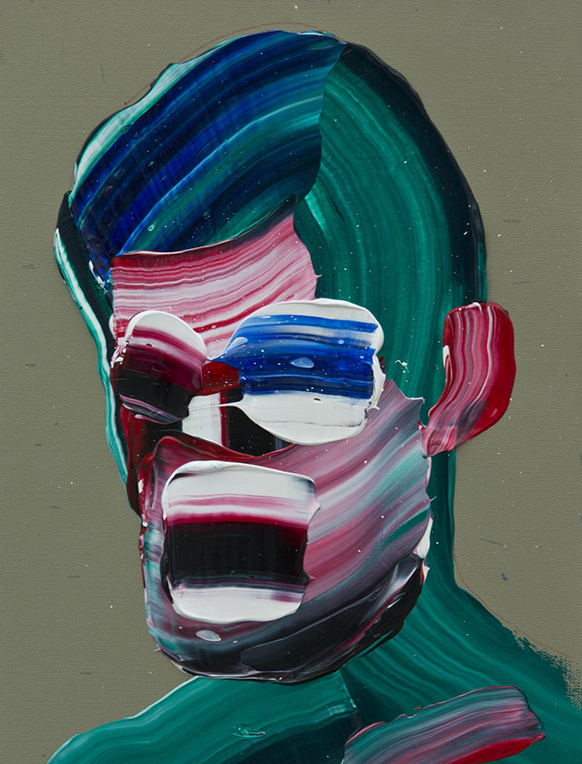

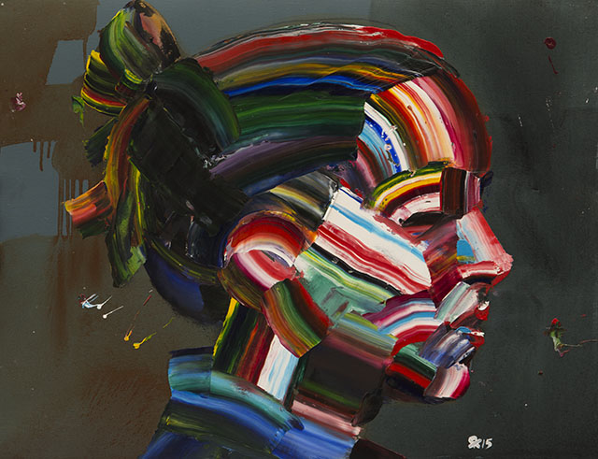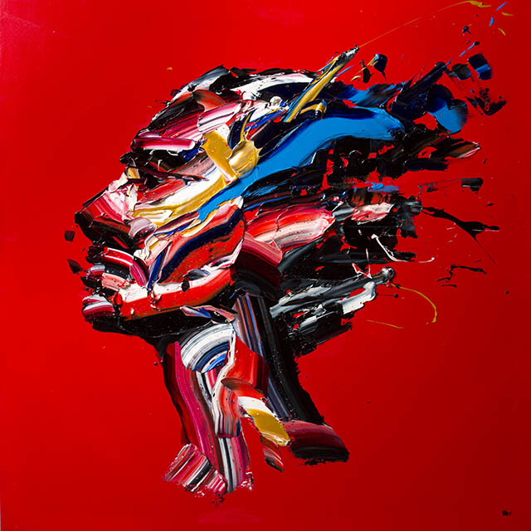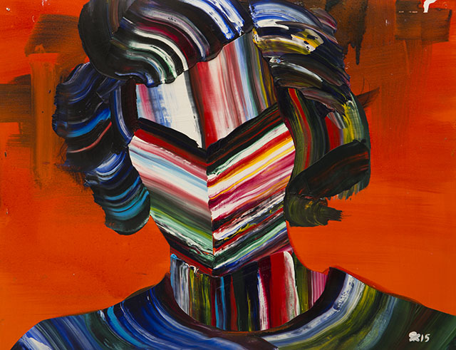

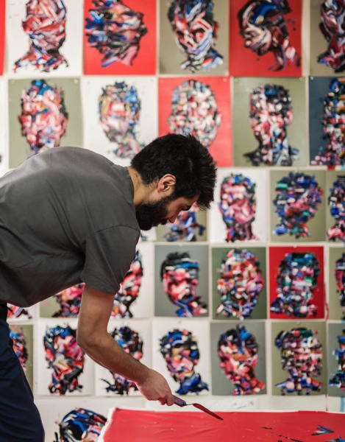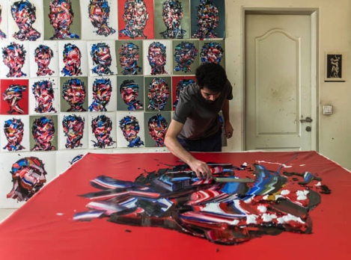

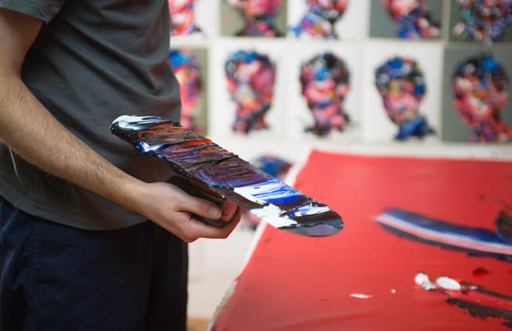

**INTERDISCIPLINARY CONNECTIONS**

Students will connect their art making to current events and social studies as we focus on an Iranian artist who creates artwork that is inspired by his country’s culture and tradition. Although students in this class may not experience the same traditions, they will gain an understanding and sense of respect for the people in this country. Students will also be able to find connections between the people in Iran and their own community, where although we are not required to cover our bodies, we still show emotion in our face and express our identity in an age of social media platforms. Students will be able to use this lesson to communicate the strong emotions that they feel and wish to show in their portrait.

# LESSON OVERVIEW

In this lesson students will learn about a present day artist, Salman Khoshroo, and his unique painting practice. Students will learn how the artist uses an uncommon painting tool to create abstract but precise portrait paintings to show emotion and expression of identity and self-representation. Students will learn how the artist uses the traditions of his country and culture to inspire and send a message through his artwork and art making process. Students will watch a presentation and then a short video from the artist’s personal E Portfolio. Then students will watch a demonstration from the teacher on how to use a palette knife and acrylic paint to create an abstract portrait painting. The demonstration will focus on tracing a side profile of well-known celebrities. Then the students will learn the important of using color to show contrast of highlights and shadows in the face. Students will also learn how to use line smears to show different facial features. Students will use the knowledge they gained from the presentation, video, and demonstration to inspire their own art making. The result of this lesson will be a deeper understanding of hos cultures and traditions influence our art making. Students will also discover how to use unique and uncommon art making tools in their personal art practice.

**LEARNER OBJECTIVES**

Students will learn about a famous artist who uses his artwork to communicate an important part of his culture and his country’s traditions.

* Students will seek inspiration from a famous artist that they transform in their own art making.
* Show emotion in the face because women must cover their entire bodies
* Expression of identity and self-representation in a time of social media

Students will use an uncommon painting tool to create abstract portraits.

* Palette knives and acrylic paint
* Use color to show contrast for highlights and shadows
* Use line smears to show different facial features

**NATIONAL ART STANDARDS**

VA:Cr2.1.Ia Engage in making a work of art or design without having a preconceived plan.

VA:Re.7.1.Ia Hypothesize ways in which art influences perception and understanding in human experiences.

VA:Re.7.2.Ia Analyze how one’s understanding of the world is affected by experiencing visual imagery.

VA:Cn11.1.Ia Describe how knowledge of culture, traditions, and history may influence personal response to art.

**PENNSYLVANIA DEPARTMENT OF EDUCATION STANDARDS**

9.1.12.F Analyze works of arts influenced by experiences or historical and cultural events through production, performance, or exhibition.

9.1.12.H Incorporate the effective and safe use of materials, equipment and tools into the production of works in the arts at work and performing spaces.

**MATERIALS NEEDED FOR LESSON**

1. **Palette knives**
2. **Acrylic paint**
3. **Paint palettes**
4. **All purpose paper**
5. **Projector**
6. **Pencils**
7. **Paper for tracing side profile silhouettes**

**TEACHER ACTIONS / EXPECTED LEARNER ACTIONS**

|  |  |
| --- | --- |
| **Teacher Actions** | **Expected Learner Actions** |
| 10 minutes: Teacher will introduce herself and welcome students into the class. The teacher will give a presentation on the artist Salman Khoshroo and his unique painting style. This will also include a 90 second video on the artist. | 10 minutes: Students will watch a presentation and video on Salman Khoshroo. |
| 5 minutes: Teacher will have the students find a space to hover around the teacher as she gives a demonstration for creating abstract portrait paintings with a palette knife. | 5 minutes: Students find a place in the room to watch the teacher give a demonstration. |
| 15 minutes: Teacher distributes materials to students. Teacher gives the students inspiration and assistance while they work. | 20 minutes: Work time |
| 5 minutes: Teacher explains clean up procedures. | 5 minutes: Students clean up their workspace. |
| 5 minutes: Teacher facilitates conversation about the students’ creations, experiences and process.  What successes did you have in your art making?  What challenges did you face with the palette knives or acrylic paint?  Will you use a palette knife again in your art making? | 5 minutes: Students engage in artistic and intellectual conversation. |

# ENDING THE LESSON

**Closure of Lesson** To end this lesson students will engage in an artistic and intellectual conversation about what they created and what they experienced during the art making process. The teacher will facilitate conversation about ask the students questions about the successes and challenges they faced during their art making. Students will be asked if they would choose to use this uncommon painting tool again in their personal art practice.

# REFERENCES TO MATERIALS CONSULTED

<http://salmankhoshroo.com/?paged=13>

<https://www.yatzer.com/salman-khoshroo>

**THE CLASSROOM AS A THIRD TEACHER**

The classroom will be set up with three large tables for students to work. There will also be a screen at the front of the room for students to watch a short presentation and video. Students will be asked to crowd around one table while the teacher gives a demonstration. Materials will also be prepared and ready for students to begin their art making as soon as the demonstration is finished.

**ASSESSMENT**

Students will be assessed on their engagement during the presentation, demonstration, and in their art making. Students will also be assessed on their ability to explore art making using an uncommon paint tool. How does the individual step out of the norm to create with a tool that is unfamiliar to him/he? How does the individual use the instructions they were given to create something they are proud of? Students will also be assessed on their ability to engage in artistic and intellectual conversation about what they created and their art making process.